



**Case Study**

**Document Retrieval Solution System (Banking)**

**Challenge**

The existing document management and retrieval system required a design that could easily identify important documents and their locations in large warehouses in minimum time. Banking systems need minimum IP (Internet Protocol) hardware to reduce security issues by embedding software onto a Radio Frequency reader to limit middleware boxes from the system. The customer also needed:

**Scalability**: To ensure the solution can accommodate future growth without disruptions.

**Data Security**: Robust measures to safeguard sensitive information.

**User Training:** Comprehensive training for smooth adoption.

**Compliance:** Adhering to industry regulations and standards.

**Cost Management:** Balancing implementation costs with long-term benefits

Illustration: reader and antenna

**Background**   
In the banking system, vast amounts of historical data are stored, necessitating significant storage capacities. Regular data retrieval is crucial for reference or compliance purposes. However, the existing system often took excessive time to identify and retrieve information, leading to inefficiencies. The process required substantial manpower to handle repetitive and monotonous tasks, increasing the risk of human error and incorrect identification of file locations within the facility.

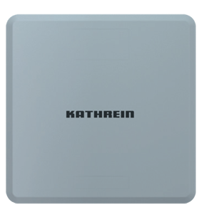

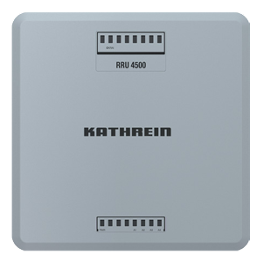

**

Illustration: Elevator Area Tracking (Setup with one reader and two antennas)

Illustration: Aisle wise tracking

**Solution**

Our solution involved implementing the standard Gate Reader concept to monitor the movement of boxes entering and exiting the facility. Installation of the Kathrein RRU4500, paired with 4xWIRA70 antennas, at entry and exit points facilitates efficient tracking of box movement. Intellistride developed specialized software capable of being embedded in low-memory readers. Embedded MQTT was developed to provide a stable platform to handle millions of transactions. Highest level of data encryption provides maximum data protection, a crucial feature in banking & other such applications.

The integration of the new system with existing infrastructure has resulted in improved accuracy and reduced downtime.

Illustration: Tracking of cart and boxes IN/OUT of premises

**Results**

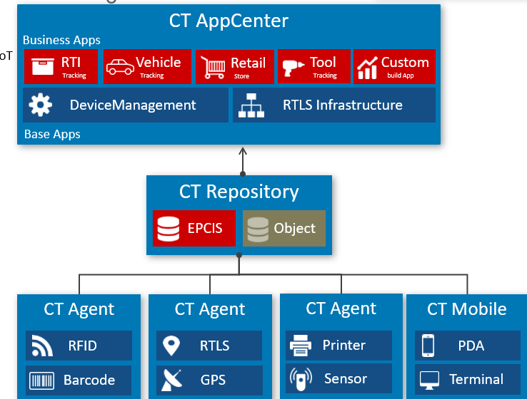The specialized software developed by Intellistride has revolutionized transaction tracking, ensuring unparalleled security and accuracy in both directions. With high-speed data processing capabilities, the system now offers faster and more precise retrieval tracking, significantly reducing delays and enhancing operational efficiency. Moreover, the implementation of plug-and-play solutions has simplified deployment and scalability, allowing for seamless replication across various applications within the banking system. Looking ahead, potential areas for expansion include geographical reach, additional software functionalities, and enhanced security measures. By continually evolving and adapting to emerging challenges and opportunities, the solution can remain at the forefront of technological innovation and meet the evolving needs of the banking industry.

Illustration: Crosstalk architecture overview

Intellistride Technologies Pvt Ltd I Prestige Infantry court Bangalore India 56001 I Phone: [+91 80 49554117](tel:+91%2080%2049554117) I [connect@intellistride.com](mailto:connect@intellistride.com) I www.intellistride.com

1M